Corporate Relations Cell (CRC) of Gautam Buddha University is the interface between GBU and the external world. It takes care of communications and collaborations with corporates, industry, organisations and government departments and ministries so as to route best of opportunities for the students of GBU.

Corporate Relations Cell is the primary tool for the students to branch out of their classrooms and explore and experiment the classroom learning. By keeping up with the latest trends and providing the latest information to the students, Corporate Relations Cell works in direction of finding best opportunities like summer training/internships, live projects, national and international events and employment vacancies for students. To compete with the current competitive environment individual counselling on a one-to-one basis, arranging seminars and group sessions concerning career choice, infusing interview skills and group discussion skills in students, and preparing resumes and draft job applications are a few of many tasks undertaken by Corporate Relations Cell.

Corporate Relations Cell team keeps a constant liaison with the various academia and Corporate establishments. It functions throughout the year towards generating placement and training opportunities for the students.

**Industry Interface:**

In its endeavour to maintain a vibrant and proactive Industry- Academia Interface, Corporate Relations Cell regularly invites reputed Industry experts from various industries, fields and domains to interact with the students and faculty of GBU. Corporate Relations Cell also organises workshops, seminars, conclaves and summits with the concerned schools which enables the students to acquire in-depth awareness of their respective fields.

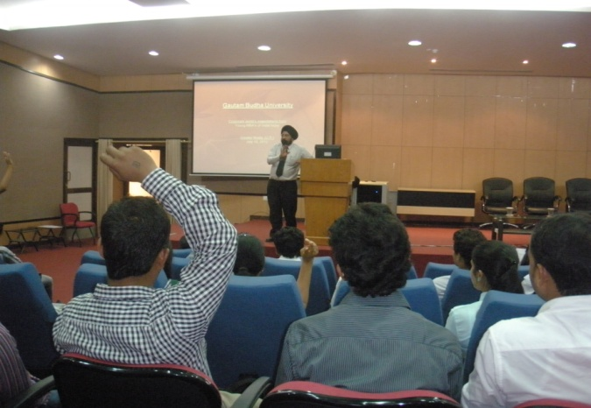 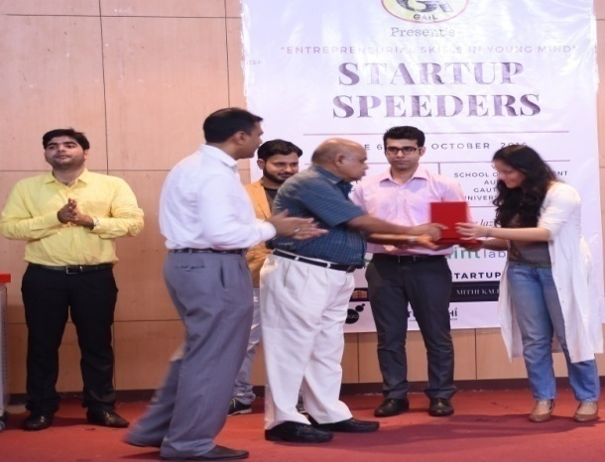

**Live Projects and Internships**:

With respect to their Summer Internship Programs, organizations such as NSIC, Graziano, Kantar Retail, CSIR, and TERI have tapped the talent pool of students from GBU for solving specific problems in these companies. Unlike the usual summer internship, these "live projects" have been taken up by students both during and between their semesters. Such Live Projects benefit both the organizations as well as students.

**Industrial Visits:**

An industrial visit provides an ideal opportunity for the students to understand the real functioning of the industry and get exposed to different work cultures. This kind of industry orientation programme provides students with insights into real life organizational dynamics and familiarizes the issues of current concern for the industry. In recent past students went to LG Electronics India Pvt Ltd. and Deki Electronics Pvt. Ltd., Jubilant foods, Mother Dairy, Graziano and Global Auto Tech.

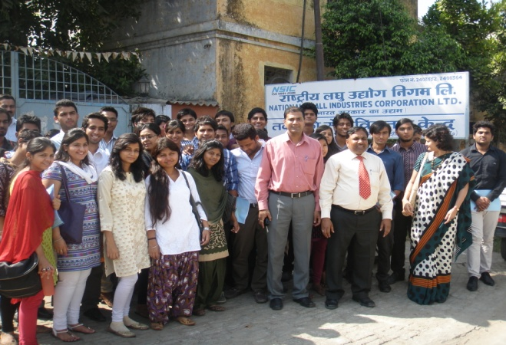 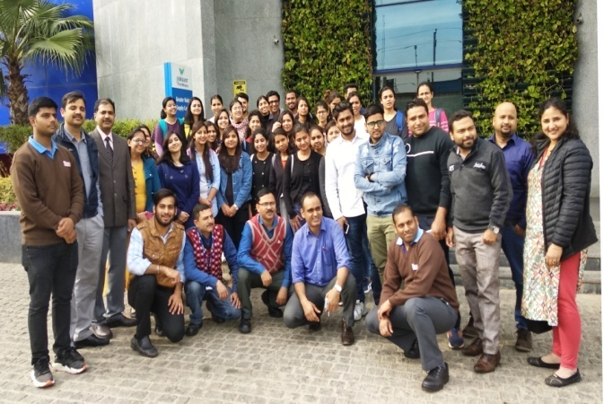  
  
  
**Placements** (Click here)

Corporate Relations Cell has a focused mandate to progressively enhance the synergies between the University & the Industry. The cell conducts regular group sessions on career choice and infuses interview skills in students to face the brutal competition in the corporate world. It is dedicated toward meeting student’s long term and short-term career goals in terms of final employment.   
  
**Entrepreneurship & Incubation**

Corporate Relations Cell in its endeavour to create an atmosphere of idea generation and entrepreneurship, has created an incubation cell. The cell has tie ups with other major incubators is the country such as the Ambuja Neotia Incubator, and has readily available funding schemes to angel investor networks. The incubation cell grooms the young entrepreneurs in skills required to start their own ventures. It also helps them achieve financial as well as managerial help from government as well as private players.

**Alumni Network**: Corporate Relations Cell also manages and cherishes the alumni networks through regular engagement via various activities.

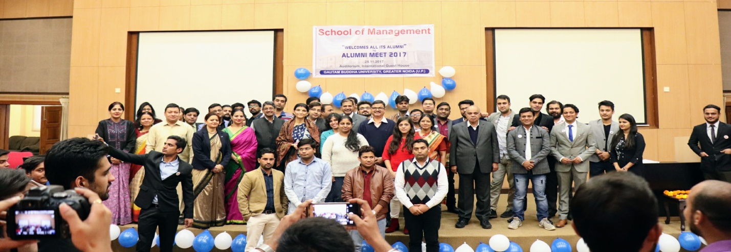

**Our Team**

University Placement Committee

* Prof. P K Yadav, Dean, Planning & Research, Chairperson
* All Schools Deans Member
* Dr Subhojit Banerjee, SoM Member
* Dr. Kavita Singh, SoM Member
* Dr. Naved Zafar Rizvi, SoICT Member
* Dr. Vimlesh Kumar, SoICT Member
* Dr. Tashfeen Ashraf, SoBT Member
* Dr. Barkha Singhal, SoBT Member
* Dr Amit Awasthi, SoVSAS Member
* Dr. Rajesh Gupta, SoVSAS Member
* Dr. Rama Sharma, SoLJG Member
* Dr. Krishna Kant Dwivedi, SoLJG Member
* Dr Anand Pratap, SoHSS Member
* Dr. Om Prakash, SoHSS Member
* Dr. Dharamvir Mangal, SoE Member
* Dr. Omveer Singh, SoE Member
* Dr. Arvind Kumar Singh, SoBSC Member
* Dr. Vinay Kumar Litoria, Manager Corporate Relations Convener
* Mr. Abhinav Sharma, Network Engineer

Dr. P.K. Yadav, Dean Planning & Research

Corporate Relations Cell

Photo: Dr. Vinay Kumar Litoria, Director Corporate Relations Cell



Photo: Shri. Abhinav Sharma, Network Engineer

Why GBU?

GBU produces responsible citizens who not only are skillful and well mannered, but also are vibrant and strong willed. The students of GBU have a strong sense of responsibility toward the nation and the family. This rare sense of appreciation and veneration for their belongingness makes them very different from the rest of the lot. Corporate partners have often appreciated the low attrition rates of the students of GBU. Because of this quality of sheer perseverance toward a cause or a vision or a mission,  GBU students have created a reputable name in the corporate arena.

**NEW PAGE**

**Entrepreneurship and Incubation**

Corporate Relations Cell in its endeavour to create an atmosphere of idea generation and entrepreneurship, has created an incubation cell. The cell has tie ups with other major incubators is the country such as the Ambuja Neotia Incubator, and has readily available funding schemes to angel investor networks. The incubation cell grooms the young entrepreneurs in skills required to start their own ventures. It also helps them achieve financial as well as managerial help from government as well as private players.

* Team Members

1. Dr. Bhupendra Chaudhary, SoBT
2. Dr. Mohd. Tashfeen Ashraf, SoBT
3. Dr. Navaid Z Rizvi, SoICT
4. Dr. Vimlesh Kumar, SoICT
5. Dr. Sandhya Tarar, SoICT
6. Dr. Lovy Sarikwal, SoM
7. Dr. Kavita Singh, SoM
8. Dr. Dharamvir Mangal, SoE
9. Dr. Omveer Singh, SoE
10. Dr. Amit K Awasthi, SoVSAS
11. Dr. Vinay Kumar Litoria, CRC

Events:

Seminar on Unleashing Entrepreneurship in India: Opportunities and Challenges with special focus on IPR on *22nd Jan, 2020 organized by MSME and PHD Chamber of Commerce.*

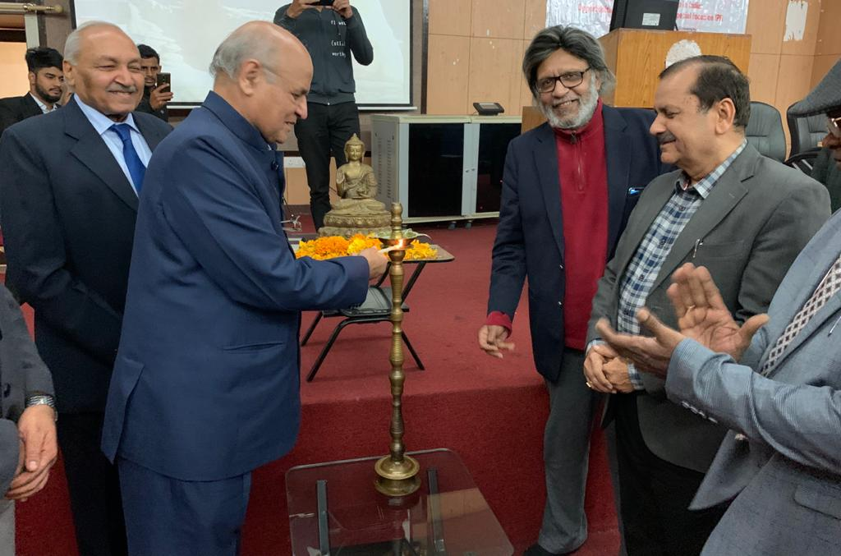 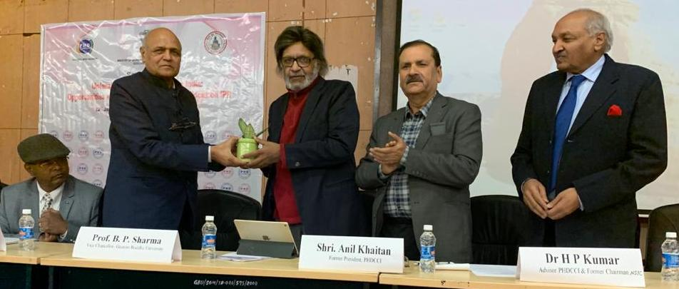

Entrepreneurship Awareness Programme & Motivation Campaign Ministry of Micro, Small and Medium Enterprises, Govt. of India is organizing an entrepreneurship awareness program to familiarize the students/ startups with various schemes of MSME on 16th January, 2020 (Thursday)

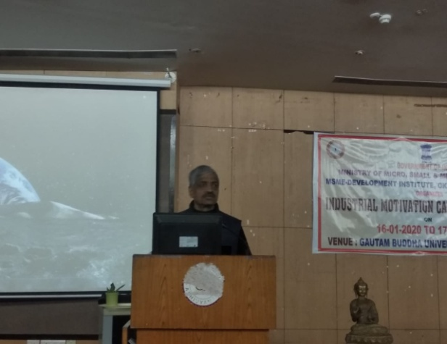 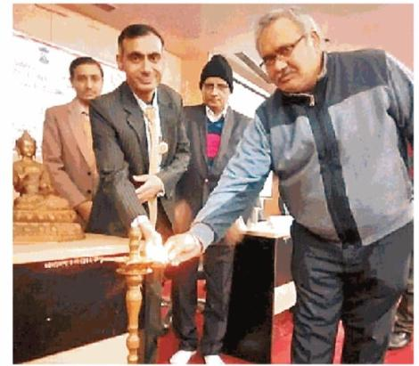

“Startup Uday” was organised in association with Swadeshi Jagran Manch on 5.10 2019. Mr. R K Chandra Sr. Advisor NIESBUD, Mr. Sanjay Bohra, Executive Director ANDC, New Delhi, Mr. Kamaljeet, and Mr. Praveen Kapoor, Mentor Swadeshi Jagran Manch.

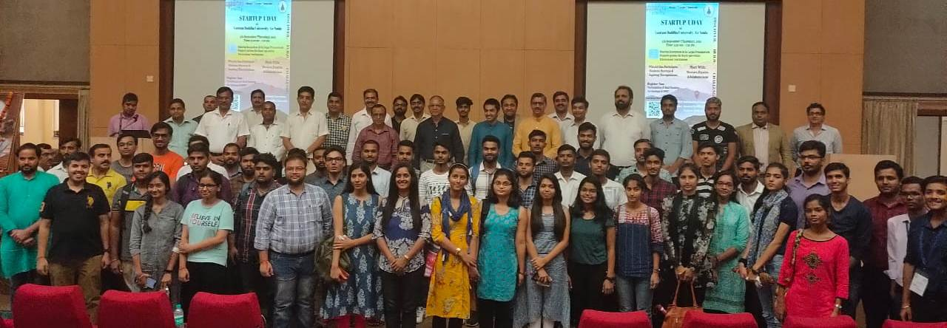

15 days Entrepreneurship Development Programme which includes one day classroom training and 14 day E-learning Module.  in association with NIESBUD, Noida, from 2nd Feb 2018 to 16th Feb 2018.

An Entrepreneurship Development Program was organized on 19th Feb, 2019 to 21st Feb, 2019 in association with NIESBUD, Noida.

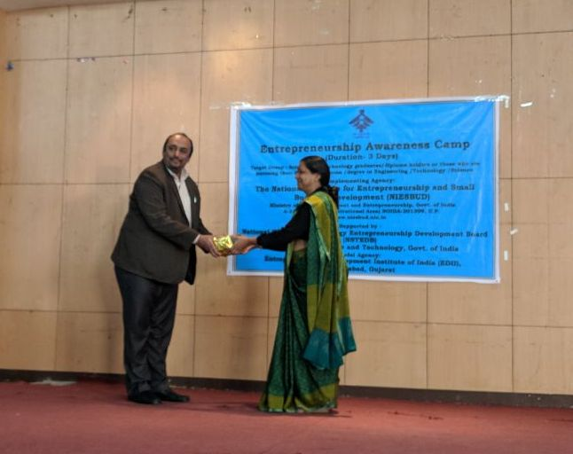 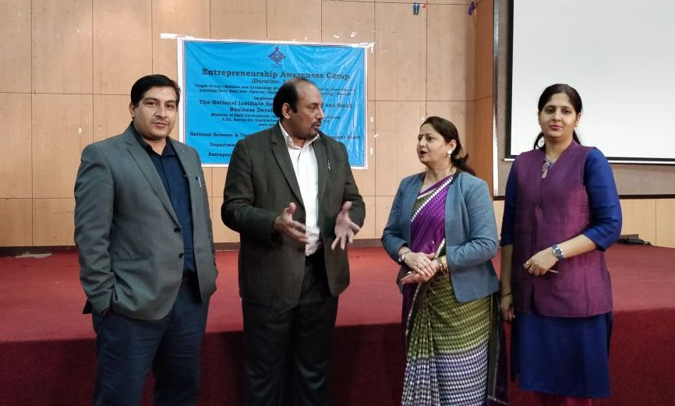

PHD Chamber of Commerce in association with Office of Controller General of Patents, Designs and Trademarks, Ministry of MSME, Govt. Of India, organized a seminar on IPR Awareness on 13th April, 2018.